User Guide

## System Requirements:

1. Windows/Linux
2. Java 8 installed
3. Any browser installed. i.e. Mozilla

## Running Application:

1. Unzip the folder – **Log-Parser**
2. Inside the **Log-Parser** folder, click on **run.bat**. See the screenshot below –

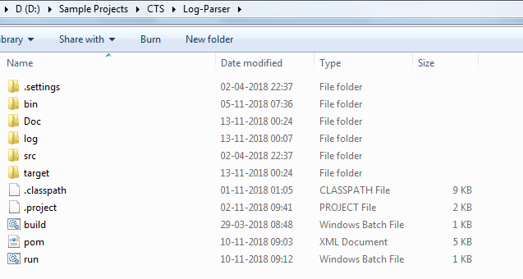

1. On clicking the **run.bat**, screen will open and would show the running status of the application-

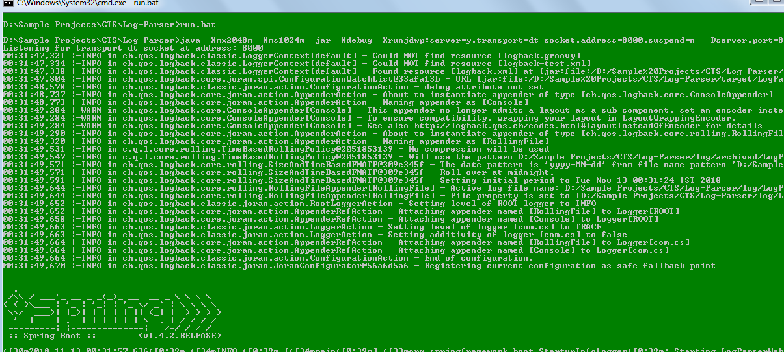

# LogParser - Overview & Features

## LogParser Listing

1. Each time you will restart the server, record will be reinitialized to zero. Due to in-memory DB H2.
2. Open browser, and navigate to the url - <http://localhost:8888/> you land to the below screen

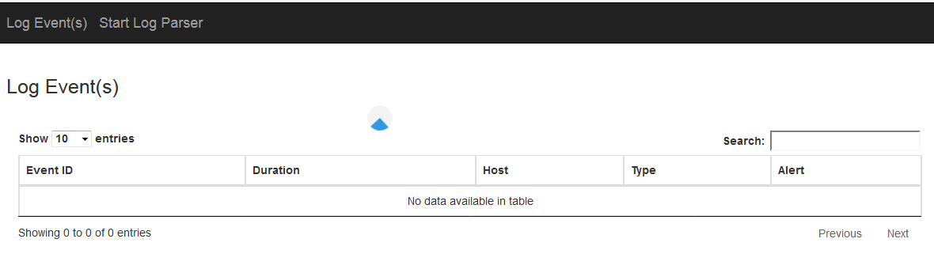

* 1. Data will keep loading while processing is going on backend. It’s refresh time is set to 10 sec.
  2. Once the backend processing are completed, loading icon will be removed indicating the end user as data processing are completed.

# Prepare Sample Json Data & Process

## Prepare Data

1. Click on **Start Log Parser** button and you will be on below screen –

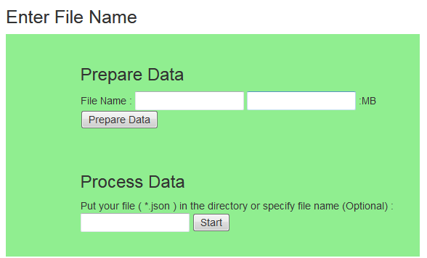

* 1. Enter the **File Name** and **File Size** which are mandatory - click on **Prepare Data**.

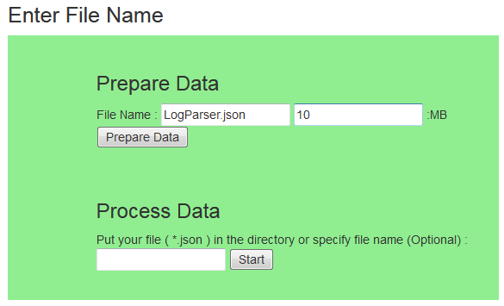

* 1. While data are being prepared, you will see the loading icon –

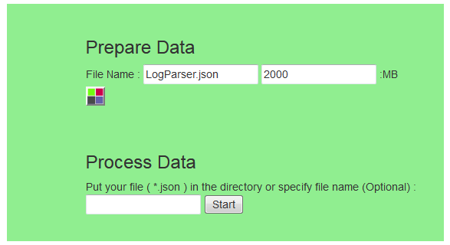

* 1. After Clicking on Prepare Data, Json data will be prepared in File- <Directory>/LogParser.json.

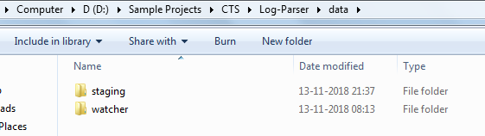

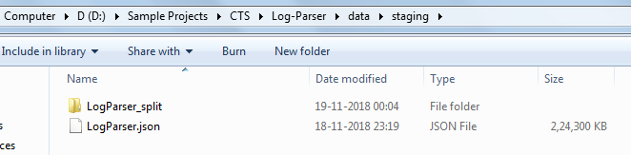

Click on **Log Event(s)** top menu to see the processing results. As soon as file is created in the configured directory, **FileWatcher** start processing the file in **Async Mode** if File Watcher is enabled in system config**.**

# Process Data

1. Once data preparation is complete, then enter the file name in Process Data section and click start, you will see the below screen –

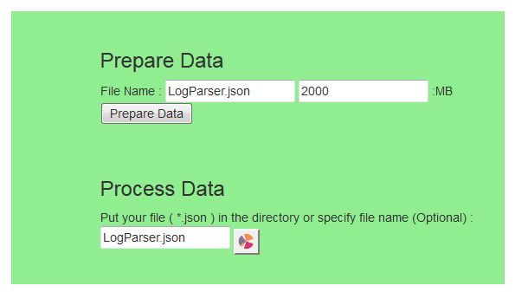

* 1. Processing of data is aync mode, so data are being processed in chunk wise and stored in directory: <FileName>_split



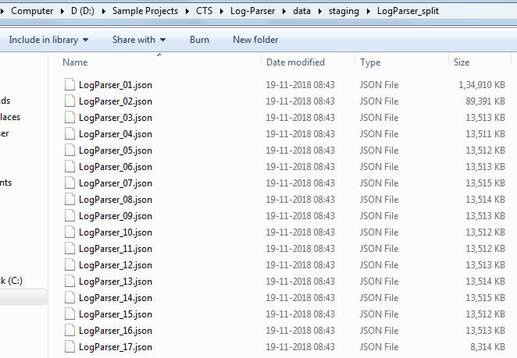

* 1. Once the chunk files are created - at the console, you will see the logs while processing as below –

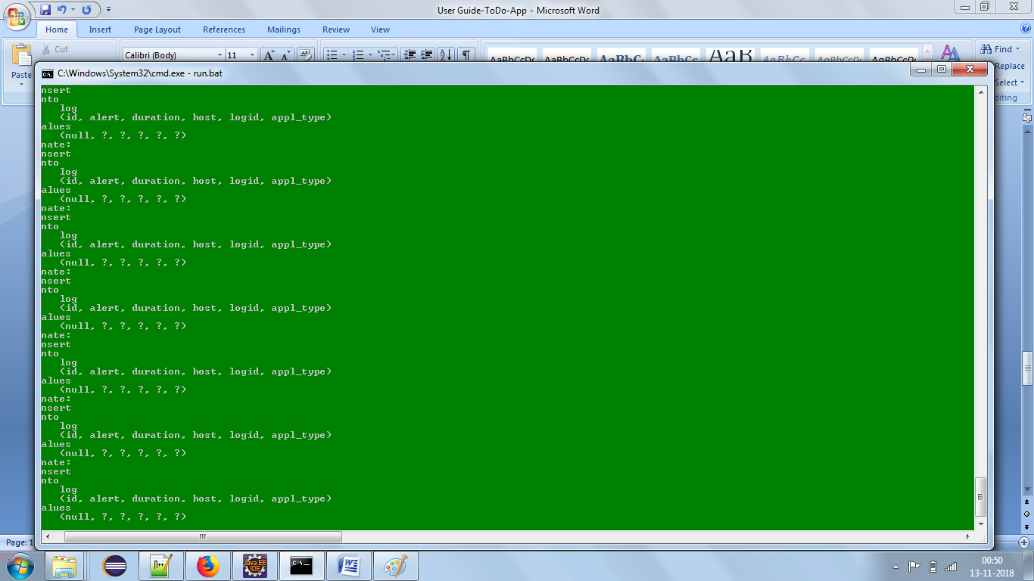

1. And data keep populated in datatable UI as below –

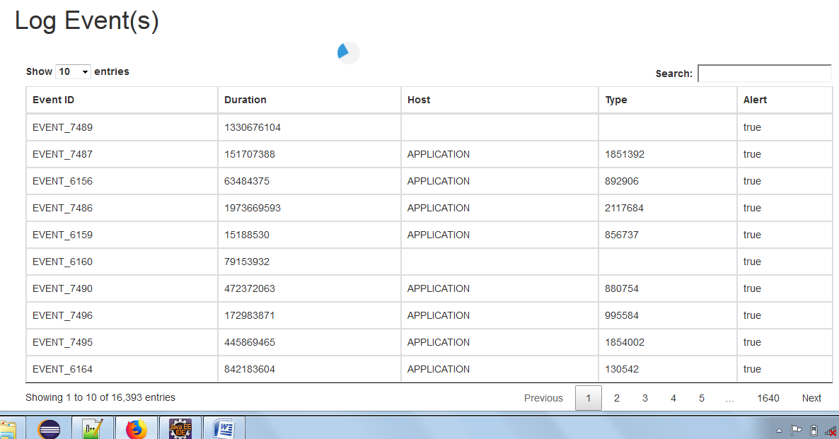

Once processing is done, loading icon will be removed.

1. If File Watcher is disabled then We can start processing of file any time by inputting the File Name as below –



1. Again switch to the Log Event(s) Menu and a thread will start to keep pulling processed data and display in Datatable. Spinner indicated processing of data is going on in async manner.



## System Configuration Management

